OFFICIAL ENTRY FORM
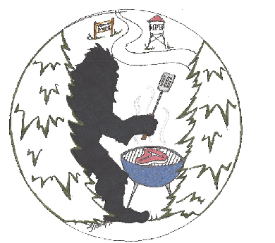
BIGFOOT BBQ CONTEST
* Saturday, July 12th, 2025 *
----------------------------------------------------
Team Name:
Cook Name:
Address:
City: State: Zip:
Phone:
Email:
Shirt Size: s m l xl xxl
Entry Fee: $150 (1 meat choice-2 full racks of ribs or 4 chickens)

**waiver of liability**
**additional meat purchase available upon request (chicken & ribs)
---------------------------------------------------------
COOKS & COMPETITORS
* Deadline is July 9th, 2025
* Meat will be provided the day of competition
* You provide your own cooker, utensils and power
* If you chose to compete, a full set of contest rules will be provided
* Official judging of competition @ 4:00 pm
*Competitors can sell BBQ all day in addition to the competition
---------------------------------------------------------
1st place - $500
2nd place - $300
3rd place - $200
MAKE CHECK PAYABLE TO:

Remer Chamber of Commerce
PO Box 303
Remer, MN 56672

For more information, email:
homeofbigfoot@gmail.com

**waiver of liability:
In consideration of your acceptance of this entry, I the undersigned, intending to be legally bound hereby, for myself, my heirs, my team, waive and release any and all rights and claims for damages I or my team may have against the Remer chamber of commerce, the City of Remer, its representatives, successors, and assigns, for any and all inquiries suffered by myself, my team, or my guests in the event. Further, I grant full permission to the event organizers and/or agents, authorized by them to uses any photographs, video tapes, recordings or any other record of the vent for any legitimate purpose. I have read the contest rules and agree to abide by the rules and regulations of the Remer Chamber of Commerce.
chief cook signature: Date:

-----------------------------------------------------------------------------------

